Program: BE
Date | June 2025 | Maximum Marks | 50
Course Code | CS362AI | Duration | 90 min
6th Sem | VI Semester | CIE-II - Scheme
Network Programming and Security

 | QUIZ | M | L | CO
1 | - 443  - Error | 2 | L3 | CO1
2 | Means we are not interested in kernel filling the client information | 1 | L3 | CO1
3 | Resolv.conf | 1 | L3 | CO2
4 | - Getservbyname  - Getaddrinfo  - Gethostbyname  - Getsockopt | 2 | L3 | CO2
5 | Convert error code to string  const char *gai_strerror (int error); | 2 | L3 | CO1
6 | Any two  - Block size  - Keysize  - Number of rounds  - Round function | 2 | L3 | CO4
Sl. No. | Test Questions | M | L | CO
1 | 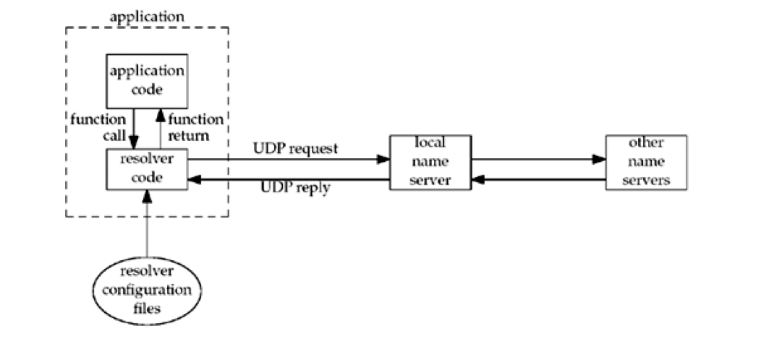  Figure + Explanation = 2+3  Resource records – 5 marks  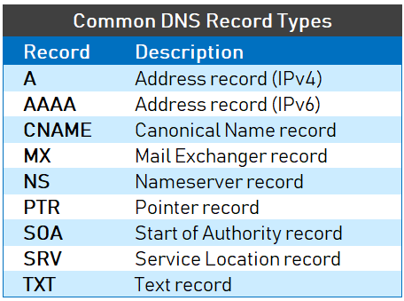 | 10 | L2 | CO1
2a | int getaddrinfo (const char *hostname, const char *service, const struct  addrinfo *hints, struct addrinfo **result) ;  hints.family = AF_INET  hints.protocol = SOCK_STREAM 4+2 | 06 | L3 | CO3
2b | Port =53  Protocol – UDP | 04 | L3 | CO2
3a | 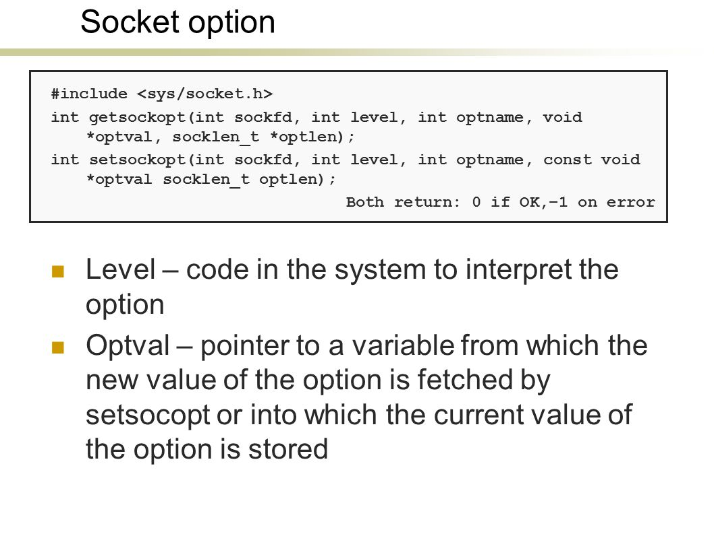 | 05 | L3 | CO2
3b | 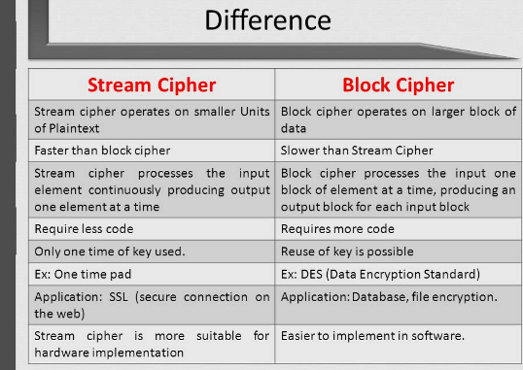 | 05 | L3 | CO4
4 | Client: socket() -> scanf(), sendto(), recvfrom()  Server: socket() ->bind() -> recvfrom()-> open()-> sendto() 5+5 | 10 | L4 | CO2
5 | 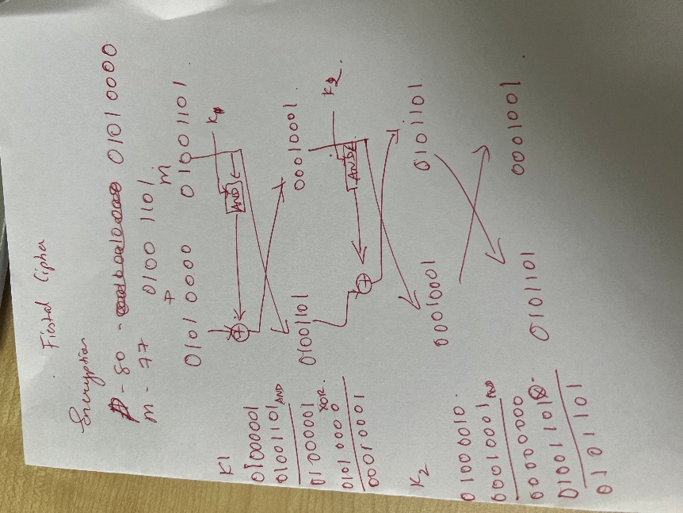 Encryption – 5marks, Decryption – 5 marks | 10 | L4 | CO5

Course Outcomes
CO1 | Explore the variety of network programming concepts and protocols.
CO2 | Analyse the interoperability of networking protocols and its usage.
CO3 | Design the client/server communication on Unix platforms.
CO4 | Investigate & Design the cryptographic algorithms to ensure secure transfer of secret keys and encryption/decryption of messages.
CO5 | Demonstrate Network Programming and Cryptographic algorithms to solve real-world problems.
Blooms’ taxonomy
L1 | L2 | L3 | L4 | L5 | L6 | CO1 | CO2 | CO3 | CO4 | CO5 | CO6
 | 10 | 30 | 20 | - | - | 15 | 22 | 06 | 07 | 10 | -

